Watch and match
Sedloňov | Castle
Gory Stolowe | 656 stairs, Hell
Skutina | DinoPark
Nové Město nad Metují | A big tree and church
Blodne Kameny | Military bunker
Karlow | Pleasant walk, views

Translate these phrases:
This year we went on holiday to Sedloňov.
The journey took 2 and half an hour.
We stayed in a cottage called Roubenka.
The accommodation was wonderful.
On the first afternoon we explored the village.
On the second day we went to a military bunker called Skutina.
The view form Velká Deštná was wonderful.
It was worth it.

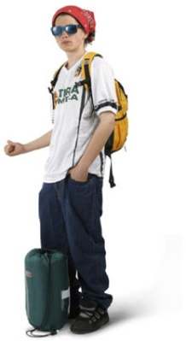
What else can you say:
This year we went on holiday _________.

to the sea.
to Croatia.
to the capital.

The journey took ______________

the whole day
three days
two hours.

We stayed __________________

in a hotel
with our friends.
in a challet.

The accommodation was_____________

wonderful.
appalling
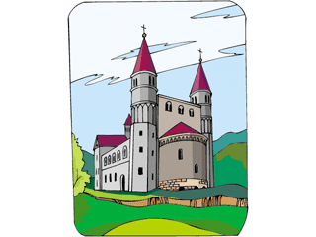
superb.

On the first day we went to_____________

a cave
to a big town
to the beach.

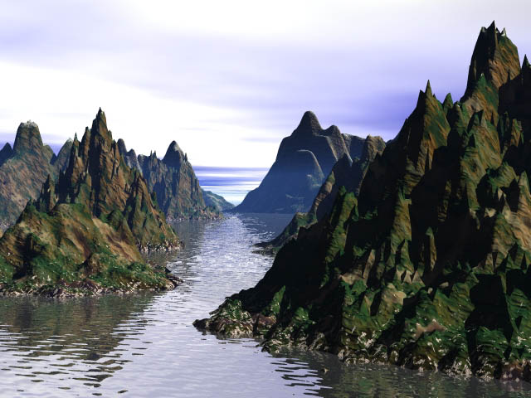
The view from the ___________ was __________

wonderful.
great.
boring.

It was worth ____________

doing.
going there.
seeing.

What do you want to say?

- This year we went on holiday _____________________.
- The journey took ______________________________
- We stayed ___________________________________
- The accommodation was____________________________
- On the first day we went to__________________________
- The view from the ___________________ was _________________________
- It was worth _______________________

Prepare a presentation about your holiday:

Teacher Notes:
The whole lesson is based upon the new approach called Messaging as proposed by George Woodward in his book Messaging.
- Start with a video. The video can be found at http://aj3000.com/wp/my-holiday-messaging-lesson/. Ask the students to watch the video and match the places and the things there. The correct answers are:
Sedloňov | A big tree and church
Gory Stolowe | 656 stairs, Hell
Skutina | Military bunker
Nové Město nad Metují | Castle
Blodne Kameny | Pleasant walk, views
Karlow | DinoPark
- Ask the students to translate the sentences from the video into their Mother Tongue.
- Go through the phrases and ask the students to repeat them and translate them. Here there would be suitable to include a memory activity for the students to remember the words. I love using random repeat or flashcards.
- Ask the students to finish the sentences in a way they want. They can use a dictionary or they can ask you. After 5 minutes elicit the language and write it on board. Students should write down the expressions they consider useful.
- Having been given all the language they should prepare a speech about their holiday. Ask them to speak for 3 minutes first to their partner. Then swap partners and they should speak for 2 minutes but they should say the same amount of sentences. Then they should swap partners again and speak for 90 seconds.

