- Translate these words:
Called |  | Similar
The same |  | Stronger
Probably |  | Lose, lost
More popular |  | Wear, wore
Again |  | Grass
Get, got |  | Than me
Wash |  | clothes
Know, knew |  | Become, became

- Read the text and decide if the sentences are True or False:
When I was a child I had a friend called Michael. We were very similar. We loved the same girls and we often fought for them. We thought that they will love the stronger one. And they probably did, because I always lost and Michael was more popular than me. One day we wore our best clothes and we fought again. And Michael won again. But we fought in grass and our clothes got green. We washed them, but our mums knew because they were green from the grass. We became friends again.
- His friend’s name was Michael.
- They often fought.
- Michael always won.
- They fought because they didn’t like each other.
- Girls didn’t like Michael.
- They washed the clothes but they were green.
- Their mothers didn’t know.

- Read this story:
When I BE a child I HAVE a friend called Michael. We BE very similar. We 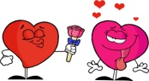 the same girls and we often 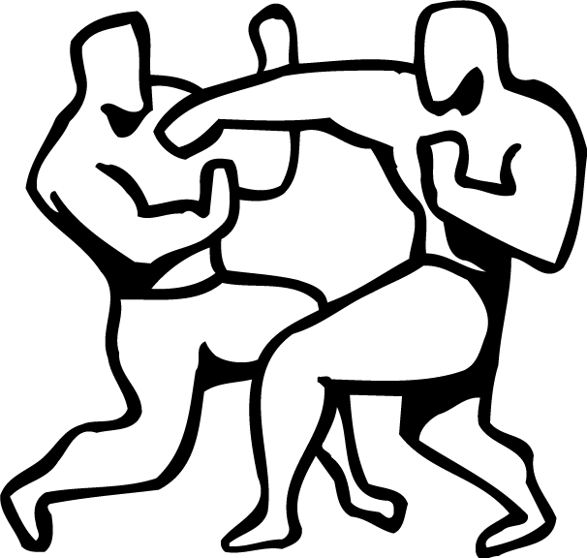for them. We that they will love the stronger one. And they probably did, because I always 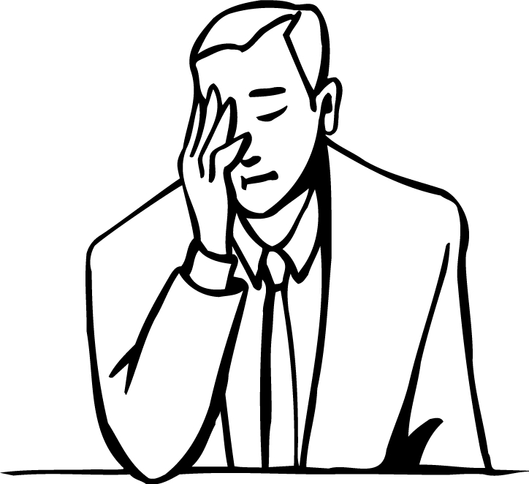and Michael BE more popular than me. One day we 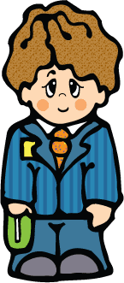our best clothes and we again. And Michael again. But we in grass and our clothes . We 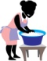them, but our mums because they BE green from the grass. We 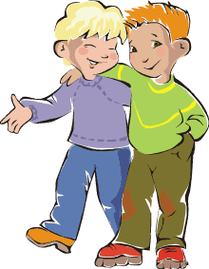 friends again.

- Crossword: Write the past tenses into the crossword
1.
2.
3.
4.
5.
Y
6.
7.
8.
9.
10.
11.
12.
13.

CLUES
1.
2. 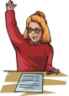
3.
4.
5.
6.
7.
8. 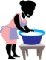
9. 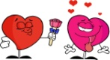
10.
11.
12.
13.

- Complete the text:
When I _________ ____ child I had ______ friend called Michael. We _______ very similar. We loved ___ __________ girls and we often __________ _____ them. We __________ ____ they will love the __________ one. And they probably did, because I always _______ and Michael was _____ popular ________ me. One day we wore our best ___________ and we fought again. And Michael ________ again. But we fought ____ ________ and our clothes got _______. We washed _______, but our mums __________ because they were green ______ the grass. We became _________ again.

